 | PES University, Bengaluru  (Established under Karnataka Act 16 of 2013) | UE17MC557
February 2019: IN SEMESTER ASSESSMENT (ISA) MCA. IV SEMESTER
TEST – 1 (Lateral Entry)
UE17MC557 – Advanced Application Development

Time: 1 hr Answer All Questions Max Marks: 20

1. | a) | Define Ecommerce. | 1
 | sol | E-commerce is the purchasing, selling and exchanging goods and services over computer networks (internet)through which transaction or terms of sale are performed electronically.
 | b) | What is purpose of using Magento ? List the key features of Magento. | 3
 | sol | Magento is an open source E-commerce software, created by Varien Inc., which is useful for online business and to create E-Commerce Websites. It has a flexible modular architecture and scalable.  Key features of Magento are:  Increased Speed  Increased Security  Improved Scaling Potential  Simpler and Faster Checkout Process  Defintion -1 Mark, Listing of key features – 2 Marks
 | c) | What is GWS? | 1
 | sol | Global – Website - Store
2. |  | Discuss the architecture of Magento with the help of a neat diagram | 1+4
 | Sol | 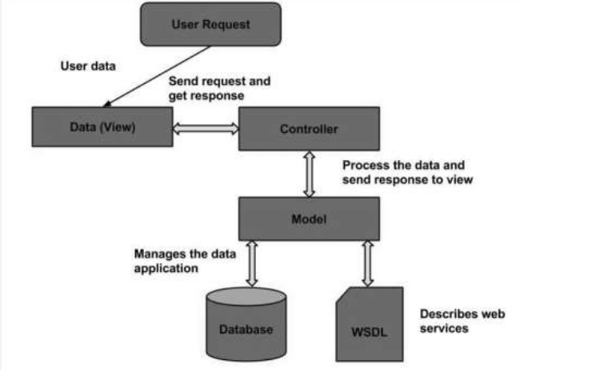  The above diagram represents Magento Architecture – 1 Mark  User Request: The user sends a request to a server in the form of request message where web browsers, search engines, etc. act like clients.  View: View represents the data in particular format. It is the user interface which is responsible for displaying the response for user request.  Controller: The controller is responsible for responding to user input and perform interactions on the data model objects.  Model: The model is responsible for managing the data of the application. It contains logic of the data and represents basic data object in the framework.  Database: Database contains the information which is requested from the user.  WSDL: WSDL stands for Web Services Description Language. It is used for describing web services and how to access them.  Explanation of components -4 Marks
3 | a) | Describe in brief how to create different categories in Magento Store. | 3
 | Sol | In order to create a new category for your products,  go to your Magento admin area > Catalog > Categories. On the left you will see the available categories (if any) and above them you will see two options - Add Root Category and Add Subcategory.  For the purpose of this section we would create a new subcategory by clicking on the Add subcategory button. You should fill in its Name, and toggle the Enable Category and Include in Menu buttons to Yes to include it in the navigation menu. These are the General Information settings for the category.  From the other tabs available you can also manage:  Content - here you may add category image, description, Add CMS Block;  Display Settings - here you can set category Display Mode, whether it is Anchor (i.e. whether or not it should inherit the products in its subcategories) and the product listing sorting options.  Search Engine Optimization - in this tab you may choose URL key, which, if set, will be used in the links to this category. This is useful for SEO purposes - when sites are indexed, it is considered a plus to have as many relative keywords as possible in the URL.  Category Products - this tab allows you to add existing products to the category  General Information Settings – 1.5 Marks, other information settings – 1.5 Marks
 | b) | What is UpSell and Cross Sell of Products? Discuss in brief. | 2
 | Sol | An upsell is to get the customer to spend more money – buy a more expensive model of the same type of product, or add features / warranties that relate to the product in question. - 1 Mark  A cross-sell is to get the customer to spend more money buy adding more products from other categories than the product being viewed or purchased. -  1 Mark
4. |  | 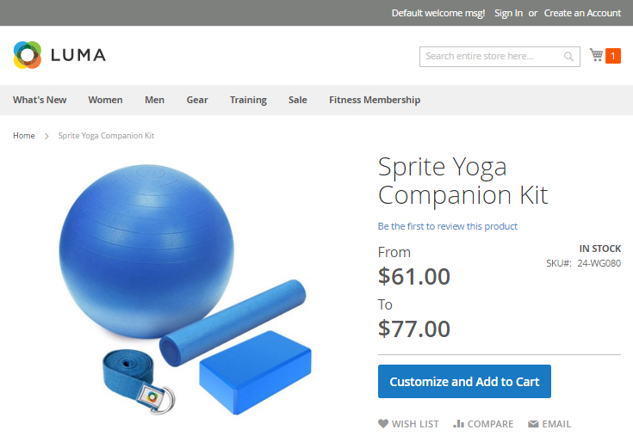  What type of product does above diagram represent? Describe steps to create such product in Magento? | 5
 | Sol | The above diagram represents bundled type product – 1 Mark  Bundled products are those products, which cannot be sold separately and doesn't give any choice to the end user. Example: Consider you want to buy a cell phone which includes earphone, memory card, battery, charging cable, etc. These are together called bundled products. These products cannot be sold individually but can be sold within the bundle product. - 1.5 Marks  Steps to create bundled products  Step 1: Select the Product Type  - On the Admin sidebar, click on Products > Inventory > Catalog.  In the upper-right corner of the Add Product menu, select Bundle Product.  Step 2: Select the Product Template  Follow one of two ways to select the product template:  - In the Search box, enter needed name of the template.  - In the list, select one of the templates you want to use  Step 3: Fill out the Require Fields  - In the Product Detail section, need to do:  - Enter the Name.  - Use the default SKU for the product, or offer another value. Then set the type of value to Dynamic or Fixed.  - To set the product Price, need to do:  - Choose Dynamic, and leave Price blank if you want the price to change according to the options selected.  - Choose Fixed, and enter the Price if you want to set price for the bundle.  - Step 4: Fill out the Remaining Product Details  - To add an image for the product group, follow one of two options:  - Drag and drop an image from your desktop on the Camera tile in the Images and Videos box.  - In the Images and Video box, click on Camera title and feel free to choose the desired image from the file on the your computer.  - The Quantity is unavailable because the product group is made up of the individual product.  - To set Weight for shipping, follow one of the options:  - Choose Dynamic, and leave Weight blank if you want the price to change according to the options selected.  - Choose Fixed, and enter the Weight if you want to set product weight.  Step 5: Add the Bundle Items  - In the Bundle Items section, set Ship Bundle Items to Separately or Together, and finally Generate the product.  5 steps – 2.5 Marks

